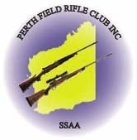
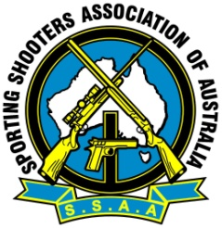
2021 SSAA (WA) Sporting Clays Championships
Sunday 11th July 2021
Hosted by
Perth Field Rifle Club
Wanneroo Shooting Complex, Perry Road, Pinjar WA

Programme: 100 Sporting Clay targets
Nominations: Adults $60 & Junior no charge. Nominations available on the day from 0830am. Competition Starts at 0900am
Rules: All events conducted under the current SSAA Rulebook. Shotgun Rule Book 4.2. Current SSAA membership cards must be shown to be eligible for prizes, Non SSAA members are able to shoot targets only.
A State team will be selected if there is a National Competition planned. Selection criteria will be vetted and approved by SSAA (WA) State Executive Committee. More guidelines will follow if a National Competition advised.
Prizes: Sash for overall High Gun and medals will be awarded in accordance with the SSAA National rule book for national championships. For example, there must be a minimum of 3 shooters per category for prizes to be awarded. SSAA WA has donated a $200 lucky door prize that is available to be won. This is open to all SSAA members competing in the championships and to any worker/helper on the day. All prizes will be presented during the awards presentation.
Facilities: Hot food, cool drinks will be available for purchase on the day. Tea, coffee & biscuits will be offered free of charge.

Contact: Neil Cobb (WA State Shotgun Delegate)
Phone: 0404040357
Email: neilcobb@bigpond.com

