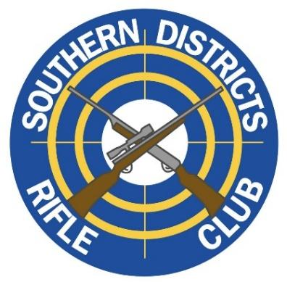
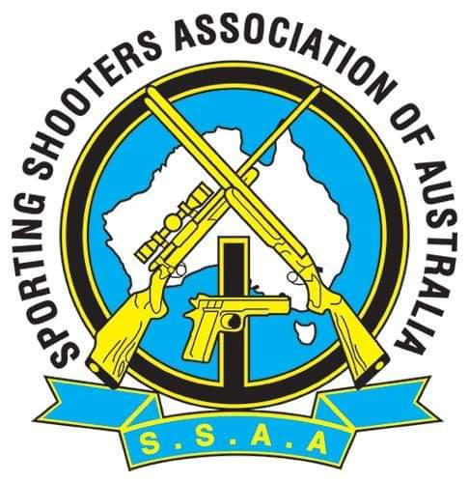

Southern Districts Rifle Club
786 Albany Hwy Bedfordale
Perth, Western Australia
Presents
Field Rifle, 3-Positional, Air Rifle and NRA 2026 National Championships
2nd to 6th April 2026
Name | SSAA Number | SSAA Branch
Address | Firearms Licence: Yes □ No □  State …………………………………………..  Lic. No.: ……………………………………… | Prohibited or Disqualified Person * Yes □ No □  Sign…………………………………………………..
* It is a requirement to provide information to the Hosting Club regarding your Firearms licence and your
eligibility to use a firearm in the State of Western Australia. It is the shooters responsibility to make themselves aware of WA Firearms Law.
Date | Event | Start time | Adult | Concession | Junior
Thur 2 Apr 2026 | Practice | 0900 - 1500 | $35 | $20 | Free
Fri 3 Apr 2026 | NRA 3x 40 | Practice 0730  Match 0800 | $35 | $20 | Free
Fri 3 Apr 2026 | 10 Mtr 3 Pos Air Rifle | On Completion of NRA match | $35 | $20 | Free
Sat 4 Apr 2026 | Field Rifle Centrefire | Practice 0900  Match 0945 | $35 | $20 | Free
Sat 4 Apr 2026 | 10 Mtr Air Rifle Precision | On Completion  of FR event | $35 | $20 | Free
Sat 4 Apr 2026 | Chairmans Meeting | On Completion
Sat 4 Apr 2026 | Dinner | 1830 | $35 | $25 | $15
Sun 5 Apr 2026 | 3 Position Rimfire | Practice 0700  Match 0745 | $35 | $20 | Free
Sun 5 Apr 2026 | Field Rifle Rimfire | On Completion  of 3P event | $35 | $20 | Free
Mon 6 Apr 2026 | 3 Position Centrefire | Practice 0900  Match 0945 | $35 | $20 | Free
Mon 6 Apr 2026 | Closing Ceremony | 1500
 | Camping Booking P/Person |  | $10 | $10 | $10
 | Total

General
- Weigh-In and Shooters’ Briefing will be held each day prior to the practice session.
- Presentations will take place on the day of each Match, following the protest period where possible.
- This event will be conducted under the current SSAA Match Rules and the SSAA National Events Cancellation and Postponement Policy.
- SSAA Membership Cards, Grading Cards, and Firearms Licences must be presented at Sign-In each day.
Nominations
Competitors are encouraged to nominate in advance prior to Friday 6th March 2026
Completed Nomination Forms can be sent either by:
- Email to secretary@sdrc.com.au or
- Post to SDRC Secretary, PO BOX 263, GOSNELLS WA, 6990
- Nomination Fees, see table above:
  - Adult $35.00 per single event.
  - Concession card holders as per the rates quoted on the nomination form.
  - Juniors – Free.
Fees may be paid by
- Bank Transfer to BSB: 036-067 Acc#: 860915 Name: SDRC.
Please use FR2026Nats along with your Surname as a reference in your bank payment or fees may be paid by cash or by eftpos on the day.
Camping
Camping is available at $10 per person for the duration of the event. Hot showers and Toilets available.
Canteen
A full canteen facility will be available from Breakfast daily.
Firearm Storage
Western Australian–compliant firearm storage is available at the club for $10 per person for the duration of the event, for out-of-state competitors only.
Please note: limited space is available — no cases or bags are permitted and competitors must provide their own trigger locks.
Contact
Please address all enquiries by email to info@sdrc.com.au

