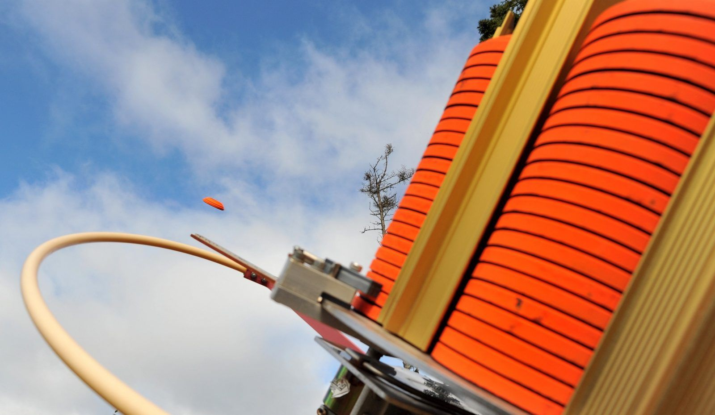
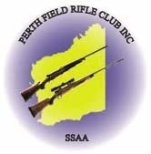
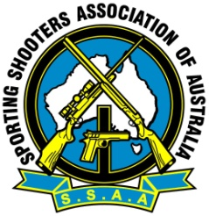
2026 SSAA (WA) Sporting State Championship
Sun 29th Nov 2026
Hosted by
Perth Field Rifle Club
Wanneroo Shooting Complex, Perry Road, Pinjar WA

Programme: 75 targets. 3 x rounds of 25
Nominations: Open - AA, A, B, C, ADULTS - $70, Juniors & Sub Juniors $40. Nominations available on the day from 0730am. Competition Starts at 0830am
Rules: Event conducted under the current SSAA Rulebook. Current SSAA membership cards must be shown to be eligible for prizes.
Prizes: Sash for overall High Gun, SSAA WA, grade medals & 2 x $100 lucky competitor door prizes all prizes will be presented during the awards presentation.
Facilities: Hot food, cool drinks and snacks will be available for purchase on the day. Tea & coffee will be offered free of charge. No EFT Facilities – Cash only
State Team: A State Team will be selected for the 2027 National Competition. Members must shoot the 2026 SSAA WA 5 Stand State Championships and the 2026 Sporting State Championships to be Eligible. The 5-person team will be selected by the SSAA WA Shotgun Chairman based on the best scores from both the 2026 State Championship scores.
2027 Nationals: TBA

Contact: Neil Cobb (WA Acting State Shotgun Chairman)
Phone: 0404040357
Email: neilcobb@bigpond.com

