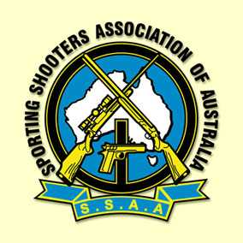
SSAA NATIONAL
Precision Target Pistol
PORT BOUVARD PISTOL & SMALL BORERIFLE CLUB INC.
14th -15th September 2024
“All adult competitors at SSAA National competitions must have the appropriate licence from their State/Territory
for the class of firearms being contested.”
Entries by Friday 6th September 2024 …………….. Please , no late entries if possible ………….

Name ………………………………………………………………………………………………....................................

Address ……………………………………………………………………………………………………………………..…

Phone …………………………..….. Mobile ……………………..………………. Fax ………………………………..

E-Mail ……………………………………………………………………………………………….

SSAA Membership Number …………………… Expiry Date.…./……/……. Branch …………………………………

Are you :- Adult [ ] Veteran 60+ [ ] Junior 11-15 yrs [ ] Over 15-18 yrs[ ]
Birth dates / ages are at time of competing .
If you are sharing a pistol, please tick the box & state with whom
SATURDAY 14 September 2024
Any Rimfire Pistol – 900 Match [ ] Sharing with ………………………………………………….
Any Revolver Match [ ] Sharing with ………………………………………………….
Distinguished Revolver Match [ ] Sharing with ………………………………………………….
SUNDAY 15 September 2024
Mayleigh Rimfire Match [ ] Sharing with ………………………………………………….
Any Centerfire Pistol - 900 Match [ ] Sharing with ………………………………………………….
CMP Service Pistol [ ] Sharing with ………………………………………………….
$8 per Event or MAXIMUM $40 - Juniors HALF PRICE

[ ] I have included payment for the above competition/s ($8 per event to MAXIMUM $40)
NB :- JUNIORS HALF PRICE
[ ] I will pay on arrival

A. Cheques / money orders made payable to:-
Port Bouvard Pistol & Small Bore Rifle Club Inc.
PO Box 363
MANDURAH WA 6210 TOTAL :- $..................

B. Please send this nomination form ASAP to:-
Port Bouvard Pistol & Small Bore Rifle Club Inc.- National Target Pistol, PO Box 363 Mandurah WA 6210
or email: secretary@portbouvardpc.com.au Please , no later than 6th September 2024.
Thank-you and we look forward to seeing you at the Championships .
SSAA Event Cancellation / Postponement Policy
An event may be postponed or cancelled at any time by SSAA Inc. SSAA WA and Port Bouvard Pistol & Small Bore Rifle Club Inc.
will not be liable for reimbursement to competitors for any costs associated with a postponed or cancelled SSAA event for any reason.
By submitting this nomination, I acknowledge and agree to the SSAA Event Cancellation / Postponement Policy.

Signature : ……………………………………………………. ..… / …..

