Sporting Shooters Association Australia
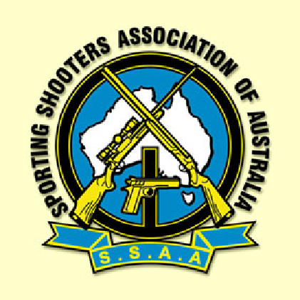
Law Enforcement Activities Division
Queensland

MATCH NOTICE

State Championship

PPC 72

8.30am Saturday 27 January 2024


Hosted and Conducted by

QUEENSLAND POLICE PISTOL CLUB

Belmont Range, Queensland

Authority
This Match Notice gives maximum notice of the series of matches and the conditions of competition. This Match Notice may serve as the official program unless changes require production of a further bulletin.
The Match Notice read with any further bulletin serves as the official program and over-rides this announcement where any changes may have been made.
Rules
SSAA Standard Rules and LEAD Guidelines
SSAA LEAD NRA USA PPC Match Rules - see NRA web site under “lecompetitions”.
As applied under SSAA LEAD PPC Rules
Match Directors discretion re conditions/conduct as per the Match Notice; but not the shooting rules
QPPC Range Standing Orders
Queensland Weapons legislation requirements.
Full Match Notice e copy available on SSAA web site or from Discipline Chairman.
Introduction
The Law Enforcement Activities discipline of SSAA creates an opportunity for interested shooters to take part in a widely inclusive competition environment which values law enforcement related interests. To this end, the Match Director may depart from some traditional customs in favour of encouraging entry level shooters.
NRA PPC Gun Divisions of Open, Distinguished and Duty apply to this match.
Open is six-inch heavy barrel rib.
Distinguished is six inch as from manufacturer.
Duty is five inch semi auto or four inch revolver as from manufacturer, on the 48 round course.
Shooters may nominate their personal choice of either revolver or semi auto.
Scrutineering will be as per NRA USA PPC .
Shooters may enter more than one division but are only eligible for awards in one. Open is not eligible for Distinguished or Duty, Open and Distinguished are not eligible for Duty.
A successful event will be one which enables the shooter to bring along his best gun and compete equitably in safe and supportive environment along with fellow shooters, including those from the law enforcement community.
Outline
Conduct of the event will be as per the Match Notice Program
Supervision will be by the SSAA LEAD State Discipline Chairman
This tournament is an individual event, there are no teams.
Gun Divisions will be as per our affiliate USA NRA.
Shooters may choose either revolver or semi auto in the NRA PPC gun divisions.
The SSAA LEAD, PPC Queensland STATE Championship will be fired over a hybrid PPC course made up of the 48 round course (Duty etc) for all, plus the 50m Stage for Distinguished and Open guns. Maximum of 72 rounds causes the hybrid course to be named PPC72. No shooting skills are lost, and the round count is approximately half. Scores are collated in the normal gun divisions.
There is no aggregate.
Eligibility of Shooters will be as per SSAA.
Conditions
Competitors are required to demonstrate familiarity with, and safe conduct of this type of course of fire including holster proficiency etc.
During the nomination process, and prior to commencement, the Match Director will cause to have documented, an acceptable, appropriate level of competence for each shooter. Some RPL may be acceptable from sources familiar with this type of event and assessment and documentation will be available on the preparation days.
Competency records will be collated for each shooter and securely retained for future reference.
The information about shooters which is necessary to collate scores will be recorded on the score sheet.
Scoring is by referees.
Shooters scores will be collated and ranked within their Gun Division.
Shooter Classification (based on a record of personal scores) will not apply at this time.
Conduct
All shooters are required for the Mandatory Range Briefing each day before firing commences.
All shooters are inherently responsible to maintain and monitor safety as well as assisting the conduct of the shoot.
Shooters undergo the course of fire as individuals, no coaching.
An independent competent referee is required for each shooter, such referee should not be drawn from the next detail.
The CRO will appoint a Detail RO to conduct each detail, detail RO’s will form up their detail, conduct their detail and retire with them so that they may have an opportunity to prepare to take part in the competition later.
Firing positions on the range will be allocated as shooters report to the range officer, ready to shoot.
As details fill up, the next detail will form up behind the bay, under the direction of their own Detail RO; they will be briefed and ready to step up as soon as the range is cleared.
Order of firing
All details will begin shooting from the closest range (3m); and move back through the various ranges.
Concurrent firing.
All gun divisions may shoot the 48 round course together.
At the completion of the 48 round courses, the Distinguished and Open guns may then fire the 50m Stage. 25m barricades will have to be removed.
Multiple details may be run to facilitate participation by shooters in extra gun divisions.
Collection of score sheets will be at end of course of fire, once submitted, score is final.
Display of scores will be at the end of the meeting and before the presentation.

Meeting
The LEAD State meeting will be held at the end of course of fire,before scores and presentation.

End Trev / Bob vers 20231222

