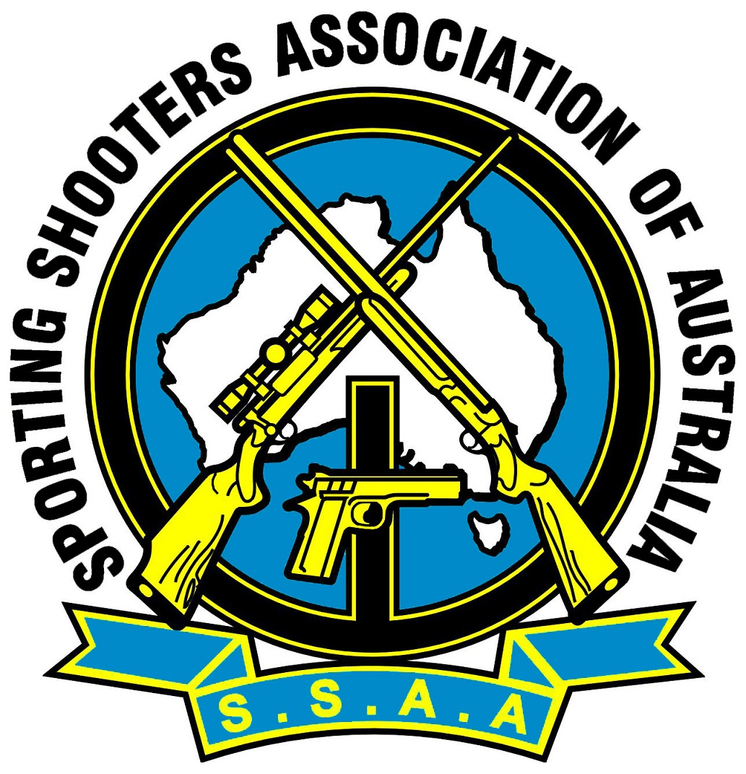
2023 Lever Action Silhouette WA
State Championships
Hosted by Hedland Sporting Shooters Club

SSAAWA & HSSC SSAA invite all interested SSAA members, to attend the
12th Lever Action Silhouette State Championships
Thursday 6th July to Monday 10th July.

Thursday 6th July: Practice Day 8.00am till 5.00pm (targets will then be reset ready for comp)
Friday 7th July: Rifle Lever Action Silhouette (80 shot match)
Saturday 8th July: Pistol Cartridge Lever Action Silhouette (80 shots).
Sunday 9th July: Small Bore Lever Action Silhouette (80 shots).
Monday 10th July Overrun day if required
(These matches may be shortened to meet time constraints if required.)

Sight in time on match days will be 7.00am – 8.15am, Morning brief 8.45am then first shot at 9.00am

All matches will be shot in accordance with the current Rifle Metallic Silhouette rulebook.
The current rule book can be found at,
https://www.ssaa.org.au/wp-content/uploads/2021/02/RIFLE_METALLIC_Rule_Book_no._8_rev_2019_-final_-_for_publication_1.pdf

The Lever Action Silhouette WA state team selection will be on the top ten positions in the Lever Action Silhouette Annual State Championship. Please see the selection criteria for further information.

Nominations will be $25.00 per 80 shot match. 3 gun will be $60.00. Juniors free.

Payments accepted on the day as long as nomination was in first, no nominations will be accepted on the day.
Nominations to be received no later than Friday 16th June 2023
Local range rules apply, whilst uncased and not in use, ALL firearms will have actions open.
Starting time on Match days will be 9.00am, pre-nominations are mandatory to assist with catering.
Canteen sales of food and drinks will be available during match days
All competitors are expected to help in some way with the running of the competition.
Medals will be awarded in all grades, trophies for two-gun, three gun and juniors.
Discipline Delegates meeting Saturday Night @ 6pm in the HSSC club rooms.
All Clubs / Branches attending need Authorisation from their club secretary in writing.
YOU MUST BE A CURRENT SSAA MEMBER, MEMBERSHIP CARDS WILL BE INSPECTED ON THE DAY
There is plenty of camping room with Shower, Toilet and BBQ facilities,
Limited Power, Meal supplied Saturday Night.

SSAAWA & HSSC SSAA invite all interested SSAA members, to attend the
12th Lever Action Silhouette State Championships
Thursday 6th July to Monday 10th July.

NOMINATION FORM

I ____________________________________________________will be shooting the following matches:

Rifle Grade _____
Pistol Cartridge Grade _____
Rimfire Grade _____

SSAA Membership Number________________________________

Range Officer Qualified Y/N
Sharing rifles? YES / NO if YES who with and which matches?

________________________________________________________________

Rifle Lever Action Silhouette: Cost $25.00 YES / NO
Pistol Cartridge Lever Action Silhouette: Cost $25.00 YES / NO
Small-bore Lever Action Rifle Silhouette: Cost $25.00 YES / NO
or $ 60.00 FOR ALL 3 MATCHES Juniors free:

Total Payment: $ ________
David Brougham 0432 748 703 clas@iinet.net.au
(State Delegate)

DON’T FORGET YOUR GRADING CARDS
All competitors are expected to help with the running of the competition.

Lever Action Silhouette WA State Team Selection Criteria
- The Lever Action Silhouette WA state team selection will be based on the Annual SSAAWA State Championship results.

- Selection will be based on the top ten positions in the Lever Action Silhouette Annual State Championship of the aggregate score of all three match categories of Rifle Cartridge, Pistol Cartridge and Rim fire Cartridge.
- The Lever Action Silhouette WA state team will consist of up to four adult members and attending juniors.
- The adult team members will be selected from the competitors with the highest ranking aggregate score from the annual “Lever Action Silhouette State Championships” that have nominated for the SSAAWA state team selection.
- The junior team members will be selected from the juniors that attend the annual Lever Action Silhouette State Championships that have nominated for the SSAAWA state team selection.
- It is expected a competitor should as a minimum achieve a top ten placing to achieve membership of the
Lever Action Silhouette SSAAWA state team. The junior member will not be expected only encouraged to achieve a top ten placing.
- Only Annual State Championships may be used as a selection shoot.
- There is no guarantee that a SSAAWA Team will qualify for yearly funding.
- All SSAAWA Teams are subject to the SSAAWA State Executive approval and discipline funding.
- It’s a competitor’s responsibility to notify the State Delegate if they wish to be considered for selection for any team as soon as possible.
- In some circumstances due to timing the previous year’s State Championship results may be used to determine selection of a team however this requires SSAAWA State Executive approval.
- The selection process should be completed by the relevant Lever Action Silhouette Discipline Delegate as soon as possible after their Annual State Championship and submitted to the SSAAWA State executive for approval

