2022 SSAA NSW Muzzleloading Championships
SSAA Bathurst - Friday 14th to Sunday 16th October 2022
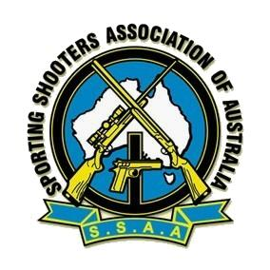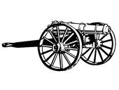
Rifle Events:
1 | 100m | BPCR | 30 min | Benchrest
2 | 100m | Class 3 - Open | 45 min | Benchrest
3 | 100m | Class 3 - Open | 45 min | Prone
4 | 100m | Class 2 - Traditional | 30 min | Benchrest
5 | 100m | Class 2 - Traditional | 30 min | X-Sticks
6 | 100m | Class 1 - Military | 30 min | Benchrest
7 | 100m | Class 1 - Military | 30 min | Prone
8 | 50m | Open | 30 min | Offhand
9 | 50m | Musket Open | 30 min | Offhand
10 | 50m | Class 4 - Firelock | 30 min | Offhand
11 | 50m | Class 2 - Traditional | 30 min | Offhand
12 | 50m | Class 1 - Military | 30 min | Offhand
13* | 50m | Class 2 - Traditional | 30 min | Benchrest – Ladies/Juniors Only
14* | 50m | Class 2 - Traditional | 30 min | X-Sticks – Ladies/Juniors Only

Pistol Events:
15 | 25m | Caplock Revolver | 30 min | Offhand
16 | 25m | Caplock Pistol | 30 min | Offhand
17 | 25m | Firelock Pistol | 30 min | Offhand

Shotgun Events:
18 |  | Caplock ML Shotgun | 25 Clays | MLAIC Trap
19 |  | Firelock ML Shotgun | 25 Clays | MLAIC Trap

Cannon Events:
20 | 25m | Cannon |  | Benchrest
21 | 50m | Cannon |  | Benchrest

All events – 13 shots, 10 to count. Extra shots – loss of highest scoring shot(s).
SSAA Muzzleloading Rulebook No. 8 to apply. Rulebook available for download from the SSAA National website.
Pre-Nominations are a must, as rostering requirements for shooters and events will be needed. Different events will be run concurrently, owing to range size and restrictions regarding distances and shooting positions. Nominations must be received by Monday 10th October, with competitors timetables for events to be emailed out and available at the range on the day.
SSAA NSW Muzzleloading Discipline AGM will be held on the Rifle Range after the conclusion of events on the Saturday afternoon.
Medal Presentation after the end of events on Sunday afternoon.
Camping is available at the range, from Thursday afternoon to Sunday. Toilet block and limited water and power available.
BBQ lunches and cold drinks are available to purchase Friday, Saturday and Sunday.
Competitors and non-shooters will be called upon to help with running the shoot. Moving and replacing targets, scoring, range officer, etc. Volunteers welcome.
Range Location:
The SSAA Bathurst range complex can be accessed off Barry Gordon Drive, which connects with the intersection of Hinton Road and Boundary Road, near Mount Panorama.
Contacts: Shayne Barnsley 0418 302 062 darth_royce@hotmail.com

